**Anjuman-I-Islam**

**M.H. Saboo Siddik Polytechnic**



**DATA structures USING C (DSU)**

**Micro project**

**Computer Engineering**

**Department**

**Co-3i**

**Title:**

**Year: 2022-23**

**Prepared by: Bank Management System**

* 210454: Shaikh Azlan Ahmed
* 210451: Abdurrahman Qureshi
* 210459: Owais Khan
* 210481: Faisal Ansari
* 220482: Chirag Gothankar

**Under the guidance of**: Mr. Mohammed Zaid



**MAHARASHTRA STATE**

**BOARD OF TECHNICAL EDUCATION**

**Certificate**

This is to certify that Mr. Azlan Ahmed Shaikh Roll no. 210454 of second semester of Diploma in Computer Engineering of institute M.H. Saboo Siddik Polytechnic(code:0002) has completed microproject satisfactorily in the subject: CGR for the academic year 2022-23 as prescribed in the curriculum.

Enrollment no: 2100020093

Place: Byculla, Mumbai

Date:_______________ Head of the department:_________



SEAL OF



INSTITUDE



________________ ________________

Subject faculty Principal



**MAHARASHTRA STATE**

**BOARD OF TECHNICAL EDUCATION**

**Certificate**

This is to certify that Mr. Abdurrahman Qureshi Roll no. 210451 of second semester of Diploma in Computer Engineering of institute M.H. Saboo Siddik Polytechnic(code: 0002) has completed microproject satisfactorily in the subject: CGR for the academic year 2022-23 as prescribed in the curriculum.

Enrollment no: 2100020112

Place: Byculla, Mumbai

Date:_______________ Head of the department:_________



SEAL OF



INSTITUDE



________________ ________________

Subject faculty Principal



**MAHARASHTRA STATE**

**BOARD OF TECHNICAL EDUCATION**

**Certificate**

This is to certify that Mr. Chirag Gothankar Roll no. 220482 of second semester of Diploma in Computer Engineering of institute M.H. Saboo Siddik Polytechnic(code:0002) has completed microproject satisfactorily in the subject: CGR for the academic year 2022-23 as prescribed in the curriculum.

Enrollment no: 2200020140

Place: Byculla, Mumbai

Date:_______________ Head of the department:_________



SEAL OF



INSTITUDE



________________ ________________

Subject faculty Principal



**MAHARASHTRA STATE**

**BOARD OF TECHNICAL EDUCATION**

**Certificate**

This is to certify that Mr. Faisal Ansari Roll no. 220481 of second semester of Diploma in Computer Engineering of institute M.H. Saboo Siddik Polytechnic(code:0002) has completed microproject satisfactorily in the subject: CGR for the academic year 2022-23 as prescribed in the curriculum.

Enrollment no: 2200020620

Place: Byculla, Mumbai

Date:_______________ Head of the department:_________

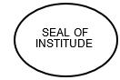

________________ ________________

Subject faculty Principal

We wish to express our profound gratitude to our guide Mr. Mohammad Zaid Sir who guided us endlessly in the framing and completion of the micro project. He guided us on all the main points in that micro project. We are indebted to his/her constant encouragement, cooperation, and help. It was his/her enthusiastic support that helped us in overcoming various obstacles in the micro-project. We are also thankful to our Principal, HOD, faculty members and classmates of Computer Engineering department for extending their support and motivation in the completion of this micro-project.

**Names of Team Members with Roll Nos.**

1. Abdurrahman Qureshi - 210451

2. Azlan Shaikh - 210454

3. Chirag Gothankar - 220482

4. Faisal Ansari - 220481

***REPORT OF MICROPROJECT***

# Rationale:

Computer graphics are pictures and films created using computers.

Usually, the term refers to computer-generated image data created with help of specialized graphical hardware and software. Some topics in computer graphics include user interface design, sprite graphics, vector graphics, 3Dmodeling, shades, GPU design, implicit surface visualization with ray tracing, and computer vision, among others. Computer graphics is made up of number of pixels.

# Aims/ Benefits of the micro-project

Computer graphics help us create realistic images that are easier to see and understand. They can create images that are more appealing to the eye. They can help reduce the time it takes to produce an image. They can help produce images that are more efficient. They can help produce images that are more accurate.

# Course Outcomes achieved

• Manipulate visual and geometric information of images.

• Implement standard algorithm to draw various graphics objects using c program.

• Develop a program to create curve using algorithms.

# Proposed methodology

* + Discussion of the given topic among group members.
  + Literature survey
  + Submission of project proposal
  + Analysis of data
  + Work divided among group members
  + Compilation of content
  + Representation
  + Editing the content as per the instructions
  + Report Preparation
  + Viva and presentation

# Action Plan

|  |  |  |  |  |
| --- | --- | --- | --- | --- |
| **Weeks** | **Details of activity** | **Planned start date** | **Planned finish date** | **Name of responsible team members** |
| 1st | Discussions & finalization of topics |  |  |  |
| 2nd | Preparation of abstract |  |  |  |
| 3rd | Literature review |  |  |  |
| 4th & 5th | Collection of data |  |  |  |
| 6th & 7th | Discussion of outline of content |  |  |  |
| 8th & 9th | Formation of content |  |  |  |
| 10th | Editing & proof reading of content |  |  |  |
| 11th | Compilation of report & preparation |  |  |  |
| 12th | Final submission of micro project |  |  |  |
| 13th | Viva |  |  |  |

* **Actual Resources used**

|  |  |  |  |  |
| --- | --- | --- | --- | --- |
| **Sr. no.** | **Name of resources** | **Specifications** | **Qty** | **Remarks** |
| 1. | Online | Learning resources and various  websites | 3 sites | - |
| 2. | Desktop | Microsoft word, Microsoft PowerPoint, Tools with internet  facility. | 1 for each | - |
| 3. | Printer | Inkjet/Laser | 1 | - |
| 4. | Stationary | Papers, Spiral  binding, Chart papers, pictures,etc. | 1 chart  paper, pictures | - |

* **Outputs of micro project**
  1. Usage of **computer graphics**
  2. Applications of **computer graphics**

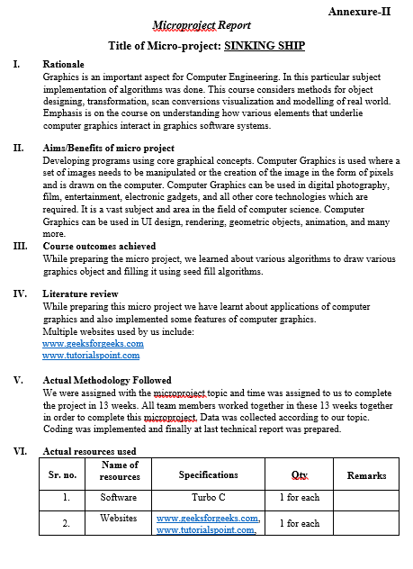

# Skills developed/Learning outcomes:

* Working in groups taking help of others and helping them too.
* Studying **computer graphics** using it.
* Looking at **CGR** more confidently and distinguishing them and stating their applications
* Enhanced skills in **computer graphics** subject.
* Designing- Designing **computer graphics** programs
* Teamwork- Learning to work in team and boost **individual confidence.**
* Time management- Completion of **micro project** as scheduled.
* Technical writing- Preparing a **report** of proposed plan.

**FLOWCHART:**

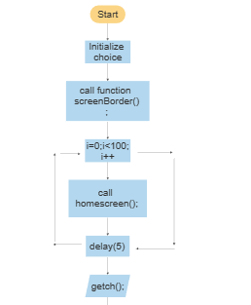 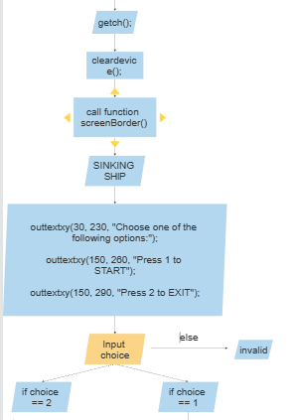

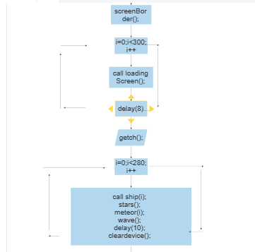 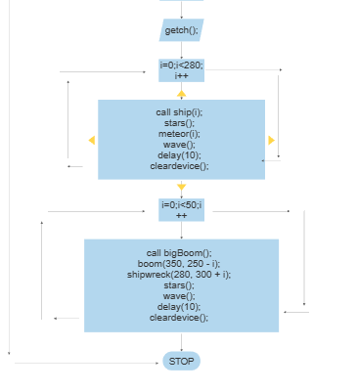

**SOURCE CODE:**

/*-------------------------------------------------------------------------------*/

// Computer Graphics Micro-Project

/*-------------------------------------------------------------------------------*/

// Header Files

/*-------------------------------------------------------------------------------*/

#include <stdio.h>

#include <conio.h>

#include <dos.h>

#include <graphics.h>

/*-------------------------------------------------------------------------------*/

// GLOBAL DECLARATIONS

int i, x = 0, y = 300, flag; // Global Variables

/*-------------------------------------------------------------------------------*/

// 210454

/*-------------------------------------------------------------------------------*/

void bfa(int x, int y, int ncolor, int dcolor);

void shipwreck(int x, int y);

void ship(int i);

void stars();

void wave();

/*-------------------------------------------------------------------------------*/

// 210451

/*-------------------------------------------------------------------------------*/

void boom();

void bigBoom();

void PROJECT();

void homeScreen();

void meteor(int i);

void screenBorder();

void loadingScreen();

/*-------------------------------------------------------------------------------*/

// Main Function

/*-------------------------------------------------------------------------------*/

int main()

{

int gd = DETECT, gm;

initgraph(&gd, &gm, " ");

PROJECT();

getch();

closegraph();

return 0;

}

/*-------------------------------------------------------------------------------*/

// Project Function --- 210451

/*-------------------------------------------------------------------------------*/

void PROJECT()

{

int choice;

setcolor(12);

screenBorder();

for (i = 0; i < 100; i++)

{

homeScreen();

delay(5);

}

outtextxy(380, 390, "Press any key to continue...");

getch();

cleardevice();

screenBorder();

// Title Part

settextstyle(0, 0, 6);

outtextxy(130, 50, "SINKING");

outtextxy(200, 120, "SHIP");

//Horizontal Border

line(0, 196, 640, 196);

line(0, 197, 640, 197);

line(0, 198, 640, 198);

line(0, 199, 640, 199);

line(0, 200, 640, 200);

line(0, 201, 640, 201);

line(0, 202, 640, 202);

line(0, 203, 640, 203);

line(0, 204, 640, 204);

// ChoicePart

settextstyle(0, 0, 2);

outtextxy(30, 230, "Choose one of the following options:");

outtextxy(150, 260, "Press 1 to START");

outtextxy(150, 290, "Press 2 to EXIT");

// Right Button

rectangle(50, 350, 250, 450);

settextstyle(0, 0, 4);

outtextxy(75, 385, "START");

// Left Button

rectangle(350, 350, 550, 450);

settextstyle(0, 0, 4);

outtextxy(390, 385, "EXIT");

scanf("%d", &choice);

while (1)

{

switch (choice)

{

case 1:

cleardevice();

screenBorder();

for (i = 0; i < 360; i++)

{

loadingScreen();

delay(8);

}

settextstyle(0, 0, 1);

outtextxy(380, 412, "Press any key to continue...");

getch();

for (i = 0; i < 280; i++)

{

ship(i);

stars();

meteor(i);

wave();

delay(10);

cleardevice();

}

// AFTER COLLISION

for (i = 0; i < 50; i++)

{

bigBoom();

boom(350, 250 - i);

shipwreck(280, 300 + i);

stars();

wave();

delay(10);

cleardevice();

}

case 2:

exit(0);

default:

printf("\n\t Invalid Choice!!!\n");

}

}

}

/*-------------------------------------------------------------------------------*/

// Ship Function --- 210454

/*-------------------------------------------------------------------------------*/

void ship(int i)

{

line(x + i, y, x + 45 + i, y + 50);

line(x + i, y, x + 150 + i, y);

line(x + 45 + i, y + 50, x + 250 + i, y + 50);

line(x + 27 + i, y + 30, x + 263 + i, y + 30);

// bfa(x + 55, y + 40, RED);

line(x + 250 + i, y + 50, x + 300 + i, y - 22);

line(x + 300 + i, y - 22, x + 200 + i, y - 22);

line(x + 200 + i, y - 22, x + 150 + i, y);

line(x + 20 + i, y, x + 20 + i, y - 80);

line(x + 50 + i, y, x + 50 + i, y - 80);

line(x + 20 + i, y - 80, x + 50 + i, y - 80);

line(x + 20 + i, y - 50, x + 50 + i, y - 50);

line(x + 20 + i, y - 30, x + 50 + i, y - 30);

line(x + 80 + i, y, x + 80 + i, y - 100);

line(x + 220 + i, y - 22, x + 80 + i, y - 100);

circle(x + 120 + i, y - 33, 10);

}

/*-------------------------------------------------------------------------------*/

// Star Function --- 210454

/*-------------------------------------------------------------------------------*/

void stars()

{

outtextxy(x + 10, y - 220, "*");

outtextxy(x + 50, y - 210, "*");

outtextxy(x + 40, y - 290, "*");

outtextxy(x + 70, y - 270, "*");

outtextxy(x + 120, y - 220, "*");

outtextxy(x + 170, y - 370, "*");

outtextxy(x + 130, y - 860, "*");

outtextxy(x + 160, y - 330, "*");

outtextxy(x + 140, y - 420, "*");

outtextxy(x + 150, y - 223, "*");

outtextxy(x + 180, y - 120, "*");

outtextxy(x + 200, y - 432, "*");

outtextxy(x + 630, y - 120, "*");

outtextxy(x + 540, y - 520, "*");

outtextxy(x + 600, y - 550, "*");

outtextxy(x + 590, y - 470, "*");

outtextxy(x + 440, y - 300, "*");

outtextxy(x + 398, y - 100, "*");

outtextxy(x + 555, y - 190, "*");

outtextxy(x + 654, y - 10, "*");

outtextxy(x + 444, y - 180, "*");

outtextxy(x + 659, y - 233, "*");

outtextxy(x + 564, y - 180, "*");

outtextxy(x + 487, y - 120, "*");

outtextxy(x + 630, y - 370, "*");

setfillstyle(1, 15);

pieslice(x + 220, y - 200, 0, 360, 35); // Moon

}

/*-------------------------------------------------------------------------------*/

// Ship Wreck Function --- 210454

/*-------------------------------------------------------------------------------*/

void shipwreck(int x, int y)

{

line(x, y, x + 45, y + 50);

line(x, y, x + 65, y); //

line(x + 65, y, x + 100, y + 30); //

line(x + 100, y + 30, x + 85, y + 50); //

line(x + 45, y + 50, x + 85, y + 50);

line(x + 130, y + 50, x + 250, y + 50);

line(x + 250, y + 50, x + 300, y - 22);

line(x + 300, y - 22, x + 200, y - 22);

line(x + 200, y - 22, x + 150, y); //

line(x + 150, y, x + 120, y); //

line(x + 120, y, x + 150, y + 30); //

line(x + 150, y + 30, x + 130, y + 50); //

line(x + 27, y + 30, x + 100, y + 30); //

line(x + 150, y + 30, x + 263, y + 30);

line(x + 20, y, x + 14, y - 30); // left

line(x + 50, y, x + 43, y - 30); // right

line(x + 14, y - 30, x + 43, y - 30);

line(x + 132, y - 60, x + 130, y);

// line(x+80,y,x+80,y-100);

line(x + 220, y - 22, x + 132, y - 60);

}

/*-------------------------------------------------------------------------------*/

void wave()

{

line(0, y + 50, getmaxx(), y + 50); // wave

setfillstyle(9, LIGHTBLUE);

floodfill(x, y + 60, 15);

}

/*-------------------------------------------------------------------------------*/

/*

void bfa(int x, int y, int ncolor){

if(getpixel(x,y) != ncolor && getpixel(x,y) != WHITE){

putpixel(x,y,ncolor);

bfa(x+1,y,ncolor);

bfa(x-1,y,ncolor);

bfa(x,y+1,ncolor);

bfa(x,y-1,ncolor);

}

} */

/*-------------------------------------------------------------------------------*/

// Meteor Function --- 210451

/*-------------------------------------------------------------------------------*/

void meteor(int i)

{

setcolor(YELLOW);

setfillstyle(1, RED);

circle(635 - i + 80, 0 + i - 80, 35); // Big

circle(635 - i + 140, 0 + i - 120, 8); // Trail

circle(635 - i + 130, 0 + i - 70, 10); // Trail

circle(635 - i + 160, 0 + i - 90, 15); // Trail

// Coloring the circles

floodfill(635 - i + 160, 0 + i - 90, YELLOW);

floodfill(635 - i + 130, 0 + i - 70, YELLOW);

floodfill(635 - i + 140, 0 + i - 120, YELLOW);

floodfill(635 - i + 80, 0 + i - 80, YELLOW);

setcolor(WHITE);

}

/*-------------------------------------------------------------------------------*/

// Explosion Function --- 210451

/*-------------------------------------------------------------------------------*/

void bigBoom()

{

setfillstyle(SOLID_FILL, WHITE);

ellipse(350, 255, 0, 180, 30, 25); // Explosion Mushroom-Cloud

ellipse(380, 280, 285, 90, 40, 30); // Explosion Mushroom-Cloud

ellipse(365, 310, 210, 360, 25, 30); // Explosion Mushroom-Cloud

ellipse(330, 300, 80, 300, 30, 30); // Explosion Mushroom-Cloud

ellipse(320, 280, 85, 235, 30, 25); // Explosion Mushroom-Cloud

floodfill(350, 280, WHITE);

}

/*-------------------------------------------------------------------------------*/

// Debris Function --- 210451

/*-------------------------------------------------------------------------------*/

void boom(int x, int y)

{

int s_angle = 180;

int e_angle = 0;

int x_rad = 0;

int y_rad = 0;

ellipse(x, y - i, s_angle, e_angle, x_rad, y_rad); // Shock-Wave

ellipse(x + 30, y - 50 - i, s_angle + 20, e_angle + 40, x_rad + 3, y_rad + 50); // Shock-Wave

ellipse(x - 40, y + 20 - i, s_angle - 90, e_angle + 180, x_rad + 2, y_rad + 30); // Shock-Wave

ellipse(x + 30, y + 20 - i, s_angle - 90, e_angle + 180, x_rad + 2, y_rad + 30); // Shock-Wave

ellipse(x + 50, y - 20 - i, s_angle + 40, e_angle + 100, x_rad + 3, y_rad + 40); // Shock-Wave

ellipse(x - 30, y + 40 - i, s_angle - 60, e_angle + 120, x_rad + 4, y_rad + 35); // Shock-Wave

circle(x + 20 + i, y - 10, 10); // Debris

circle(x + 40 - i, y + 20, 10); // Debris

circle(x + 30 + i, y - 50, 10); // Debris

delay(10);

}

/*-------------------------------------------------------------------------------*/

// Loading Function --- 210451

/*-------------------------------------------------------------------------------*/

void loadingScreen()

{

screenBorder();

// Loading Text

settextstyle(0, 0, 3);

outtextxy(70, 50, "Get ready to witness");

outtextxy(70, 80, "the sinking SHIP!!!");

// // Outer Circle

// ellipse(310, 250, 90 + i, 100 + i, 70, 70); // Loading Arcs

// ellipse(310, 250, 90 + i, 100 + i, 69, 69); // Loading Arcs

// ellipse(310, 250, 90 + i, 100 + i, 68, 68); // Loading Arcs

// ellipse(310, 250, 90 + i, 100 + i, 67, 67); // Loading Arcs

// // Inner Circle

// ellipse(310, 250, 90 - i, 100 - i, 30, 30); // Loading Arcs

// ellipse(310, 250, 90 - i, 100 - i, 29, 29); // Loading Arcs

// ellipse(310, 250, 90 - i, 100 - i, 28, 28); // Loading Arcs

// ellipse(310, 250, 90 - i, 100 - i, 27, 27); // Loading Arcs

outtextxy(100, 350, "Loading...");

rectangle(99, 379, 549, 391);

for (i = 0; i < 448; i++)

{

rectangle(100 + i, 380, 548, 390);

delay(10);

}

}

/*-------------------------------------------------------------------------------*/

// Home Screen Function --- 210451

/*-------------------------------------------------------------------------------*/

void homeScreen()

{

screenBorder();

settextstyle(0, 0, 4);

outtextxy(50, 70, "Computer Graphics"); // Title

outtextxy(50, 130, " Micro-Project"); // Title

//Horizontal Border

line(0, 210, 640, 210);

line(0, 211, 640, 211);

line(0, 212, 640, 212);

line(0, 213, 640, 213);

line(0, 214, 640, 214);

line(0, 215, 640, 215);

line(0, 216, 640, 216);

line(0, 217, 640, 217);

line(0, 218, 640, 218);

line(0, 219, 640, 219);

settextstyle(0, 0, 2);

outtextxy(120, 270, "Guided By Mr. Zaid"); // Faculty

settextstyle(0, 0, 1);

outtextxy(120, 320, "210451---Abdurrahman Qureshi"); // Participants Roll No

outtextxy(120, 340, "210454---Azlan Shaikh"); // Participants Roll No

//outtextxy(120, 360, "210451"); // Participants Roll No

}

/*-------------------------------------------------------------------------------*/

// Border Function --- 210451

/*-------------------------------------------------------------------------------*/

void screenBorder()

{

// Top Border

line(0, 1, 640, 1);

line(0, 2, 640, 2);

line(0, 3, 640, 3);

line(0, 4, 640, 4);

line(0, 5, 640, 5);

line(0, 6, 640, 6);

line(0, 7, 640, 7);

line(0, 8, 640, 8);

line(0, 9, 640, 9);

line(0, 10, 640, 10);

// Bottom Border

line(0, 471, 640, 471);

line(0, 472, 640, 472);

line(0, 473, 640, 473);

line(0, 474, 640, 474);

line(0, 475, 640, 475);

line(0, 476, 640, 476);

line(0, 477, 640, 477);

line(0, 478, 640, 478);

line(0, 479, 640, 479);

line(0, 480, 640, 480);

// Left Border

line(0, 0, 0, 480);

line(1, 0, 1, 480);

line(2, 0, 2, 480);

line(3, 0, 3, 480);

line(4, 0, 4, 480);

line(5, 0, 5, 480);

line(6, 0, 6, 480);

line(7, 0, 7, 480);

line(8, 0, 8, 480);

line(9, 0, 9, 480);

// Right Border

line(631, 0, 631, 480);

line(632, 0, 632, 480);

line(633, 0, 633, 480);

line(634, 0, 634, 480);

line(635, 0, 635, 480);

line(636, 0, 636, 480);

line(637, 0, 637, 480);

line(638, 0, 638, 480);

line(639, 0, 639, 480);

line(640, 0, 640, 480);

}

**OUPTUT:**

